

Government Blockchain Association

Government Blockchain Ecosystem (GBE)

Date: 3/21/2020 (revised 4/15/2020)

Version Draft

Version 0.21

This paper is a product of the Government Blockchain Association (GBA). It is intended to be used as a means of capturing ideas and suggestions. It does not contain any official position, intent, or commitment by any individual or group associated with the GBA. It is purely informative and not declarative in any manner. Any declarative statements do not contain the authority or approval of any member or contributor.

Any questions or inquiries about this whitepaper should be directed to the GBA CTO, [Mark Waser](https://www.gbaglobal.org/members/mark-wasergmail-com/profile/) at mark.waser@gmail.com.

Contents

1 Executive Summary 1

2 Introduction 1

2.1 Purpose 1

2.2 Problem Statement 1

2.3 Government Business Blockchain Platform (GBBP) 1

2.4 Strategy 2

2.5 Platform Governance 2

2.6 Why the GBA 2

3 Blockchain Governance Plan - DAO 3

4 Implementation Plan 3

4.1 Blockchain Backbone Implementation 3

4.2 Initial Public Funding 3

4.3 Application Development 4

4.4 Establish Government Marketplace 4

4.5 Commission Government Blockchain Platform 4

5 Technical Details 4

5.1 Blockchain Architecture 4

**Appendixes**

|  |  |
| --- | --- |
| A | Use Case Development Schedule |
| B | GBBP Application Requirements |
| C | Glossary |
|  |  |

# Executive Summary

The Government Business Blockchain Platform (GBBP) is a multi-blockchain platform that is being developed as a common environment for GBA members, chapters and working groups to use to develop and deploy blockchain applications for government. GBA members build gateways to various blockchains and the GBBP supports applications that can transport information and assets across the connected blockchains. This will enable GBA members to build distributed applications for government functions like licensing, permitting, acquisition management, contract management, grant management, and voting. The core asset that initially moves across the platform is the GBA Token. The platform and the token work together to form a Government Blockchain Marketplace available for government offices to be able to acquire configurable applications from GBA members. Once mature, this marketplace should enable government offices to acquire blockchain-based business applications quickly and more efficiently.

# Introduction

## Purpose

The purpose of this document is to describe the concept of the Government Blockchain Business Platform (GBBP). It provides a high-level explanation of the motivation for building it, and detail the features, benefits, and high-level strategy for its development, deployment, and operation.

## Problem Statement

Almost all governments perform similar government business functions including:

* Acquisitions management
* Appropriations
* Asset management
* Auditing
* Border Security
* Budgeting
* Collecting revenue
* Contract management
* Emergency Management
* Grants management
* Inventory management
* Legal & regulatory oversight
* Licensing
* Permitting
* Voting

Unfortunately, many government entities establish and maintain redundant systems that duplicate these functions. For example, virtually every government office at the local, state/province, national, and international level maintains a septate contract management system. The duplication of the same function across tens of thousands of government entities results in enormous waste. This results in higher costs and either greater debt or higher taxes.

Governments are not the only parties negatively impacted by this eclectic and inefficient government eco-system. Government contractors, citizens, and organizations waste enormous resources because of the limited interoperability of government systems. For example. Moving from one state to another requires re-registering in countless systems and often results in delays and loss of revenue, and productivity.

## Government Business Blockchain Platform (GBBP)

The GBBP is a cross-blockchain platform administered by the Government Blockchain Association (GBA). It is vendor neutral and comprised of nodes and gateways that connect to other blockchains and distributed ledgers like Ethereum, Hyperledger, STEEM, Hive, EOS, and many others. This architecture allows government agencies to segregate confidential data on their own servers and still share data with other government entities like contractor performance data.

The system is designed to charge government applications a miniscule usage fee that can be automatically passed on to users, along with additional government assessed fees, if desired. Usage fees are used to compensate node/gateway owners and application developers for their support of the GBBP.

Applications on the platform that are the most used generate more incentive for innovators to develop better services for government. Fees are collected in fiat currency or Ethereum, converted to cross-blockchain Ethereum-based tokens for use, and distributed to service providers via smart contracts.

## Strategy

The GBBP is operational and currently being enhanced to add more blockchains and dApps using the [GBA Token](https://www.gbaglobal.org/the-gba-token-pilot-project/). The blockchain network currently consists of GBA members who have volunteered to host nodes until external funding and/or hosts are available. The GBA is planning a series of innovation challenges to encourage the development of government services applications to be developed on the platform. As more applications become available on the platform, governments will have greater incentive to use the platform to interoperate with other government entities. This should result in less friction, better performance of government services and lower costs for taxpayers.

## Platform Governance

The GBBP is distributed and decentralized. However, initial governance of the platform will be administered by the Government Blockchain Association (GBA) though most decisions will be made using consensus algorithms and protocols. The GBA’s role is not to make decisions. Instead, the GBA’s role is to ensure that decisions are made via the appropriate protocols and in accordance with the following governance principles:

* All entities shall have a right to safeguard and restrict proprietary data to protect privacy
* All entities may share their data at their own discretion
* All shared data shall be accurate
* Community roles are established and maintained that define access and usage rights
* All members of the community are bound by the public rule set that defines the consensus protocols.

While the GBA is initially responsible for facilitating the overall governance of the platform and ecosystem. Eventually the platform will be managed using the principles of a Distributed Autonomous Organization (DAO). In this way, no single organization will have dominance over another entity on the GBBP. This governance structure is implemented by establishing a framework, rules, proposal process, voting mechanism, selection and implementation process that ensures that all protocol decisions are open, transparent, and rules based.

## Why the GBA

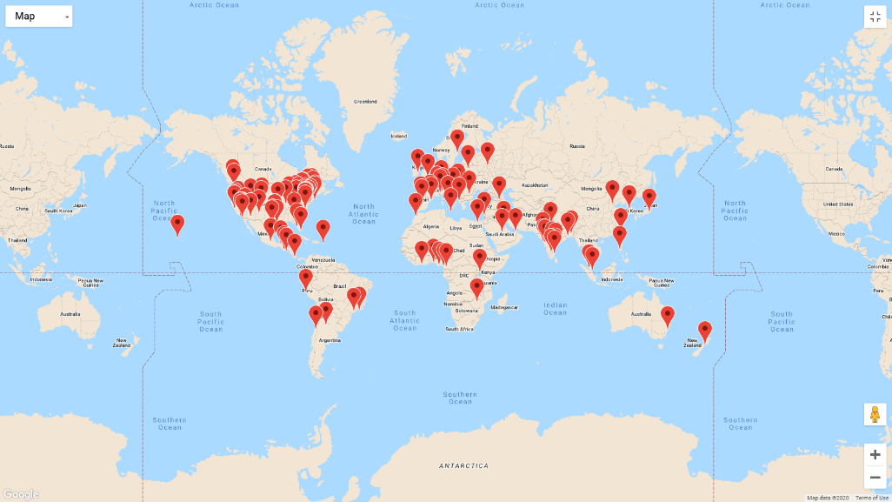The GBA is an international Non-Governmental Organization (NGO) with thousands of members in over 100 cities globally. The organization is free for all civil servants and charges a nominal membership fee for private sector individuals and organizations. The membership includes public and private sector blockchain and government leaders at the local, state/provincial, national and international levels of government. The organization is a membership driven organization with distributed and decentralized management structure and has over 50 working groups focused on government use cases.

# Implementation Plan

The plan to develop, implement and deploy the GBBP includes the following major phases:

* Blockchain Backbone Implementation (complete)
* Initial Public Funding
* Application Development
* Establish Government Marketplace
* Commission Government Blockchain Platform

They are described in more detail below:

## Blockchain Backbone Implementation

The [GBA Mining & Cryptocurrency Working Group](https://www.gbaglobal.org/groups/mining-cryptocurrency-working-group/) has been discussing and developing a GBA Token since 2018. That project examined the development of a reward token that could be used to incentivize GBA members for making contributions to the GBA community. The GBBP was developed as a platform to allow for the movement of multiple tokens (payment, reward and test/training/demonstration) across various existing blockchains so that it could be blockchain agnostic. As that blockchain was being developed, it became evident that the GBBP could be used for a wider variety of government business functions. Currently the GBBP is functional with several GBA members hosting nodes and gateways.

## Initial Public Funding

The project started as a volunteer effort where collaborators from across the GBA membership met, discussed, designed, and implemented the initial blockchain backbone. The second phase of the project includes the solicitation and acquisition of grant funding to build out the first set of government business capabilities. See Appendix A for the Use Case Development Schedule.

## Application Development

The GBA plans to use funds collected from grants to administer GBBP **Innovation Challenges**[1]. These challenges will be contests like hackathons. However, they will allow for more time for teams to develop larger and higher quality submissions. The GBA CTO will coordinate with the GBA Working Group PMO and publish the technical specifications, challenge rules, and award selection criteria. The GBA Director, of Chapter Operations will be responsible for communicating the information to GBA Regional Leads and Chapter Leaders.[2]

Once the submissions are received and verified to satisfy deployment criteria, the prize(s) will be awarded, and all qualifying submissions will be added to the GBBP.

## Establish Government Marketplace

The GBA will establish a user interface where government entities can access applications on the GBBP and interact directly with the applications with the proper permissions. Although applications will be available across the platform, data will be siloed and often limited to nodes under a specific agency’s control so as to fulfill the necessary security and privacy requirements.

## Commission Government Blockchain Platform

The GBA will work with government entities, GBA members, and other stakeholders to facilitate the approval of security certifications and other requirements to gain approval to operate GBBP applications in government environments. Once all defined requirements are met, GBA will support the promotion and wide scale adoption of the government business applications to GBA civil servants and government organizations.

# Technical Details

## Blockchain Architecture

The GBBP is a hub-and-spoke multi-blockchain platform. Gateways between the GBA hub and other blockchains (the spokes) are established based on a set of rules established and maintained by the GBA. The GBA hub maintains:

* Code that calculates and verifies the distribution & allocation of assets on the blockchain
* Shared ledger of the on-chain wallets, assets and balances on each linked blockchain platform.

Each gateway is linked with an existing blockchain platform. Each gateway includes an audit interface but no other interface to reduce the attack surface.

Full gateways allow for assets to be moved between all of the connected blockchains from the GBA wallets. Limited gateways may require a wallet on the connected blockchain to initiate transfers. Both will allow the ordering of services on any connected blockchain from any connected blockchain. The network is linked to the public Ethereum blockchain and a pegged Ethereum token (pEth) will be used as a utility token to pay fees and buy services or other tokens.

The diagram below describes the interactions between the GBA, the connected blockchains and the GBA wallet.

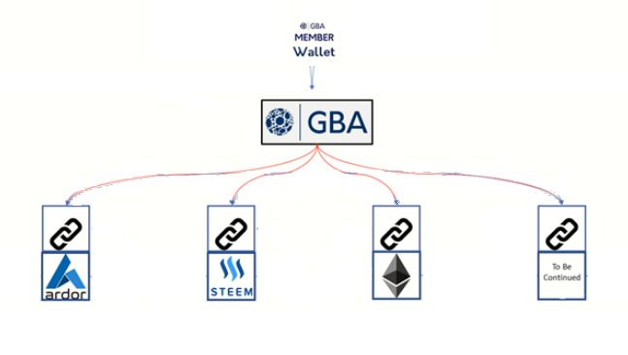

| **Use Case Development Schedule** | | |
| --- | --- | --- |
| **Date** | **Title** | **Requirements** |
| APR 2020 | Certification | See Appendix B: GBBP Application Requirements |
|  |  |  |
|  |  |  |
|  |  |  |

| **GBBP Application Requirements** | | | |
| --- | --- | --- | --- |
| **ReqID** | **Business Function** | **Feature** | **References** |
| 1.1.0 | Certification | 8 (A) - Small Business | [SBA](http://www.sba.gov/federal-contracting/contracting-assistance-programs/8a-business-development-program) |
| 1.2.0 | Certification | Minority Owned Business (MBE) | [Maryland](http://www.mdot.maryland.gov/newMDOT/MBE/Documents/MBE%20Only%20App%202020.pdf)  [Maryland Application](https://mbe.mdot.maryland.gov/apply/) |
| 1.3.0 | Certification | National Minority Supplier Development Council (NMSDC) | [NMSDC](https://nmsdc.org/mbes/mbe-certification/) |
| 1.4.0 | Certification | Disabled Owned Business Enterprise (DOBE) | [SBA SDVO Small Business](https://www.sba.gov/federal-contracting/contracting-assistance-programs/service-disabled-veteran-owned-small-businesses-program) |
| 1.5.0 | Certification | Woman-Owned Business Enterprise (WBE) | [Baltimore City](https://law.baltimorecity.gov/sites/default/files/law/attachments/MBEWBE_%20New%20Certification_Application%20v%203.1_0.pdf) |
| 1.6.0 | Certification | Veteran-Owned Business Enterprise (VOSB) |  |
| 1.7.0 | Certification | Hispanic-Owned Business Enterprise (HOBE) |  |
| 1.8.0 | Certification | Hub Zone Business Enterprise (Hub Zone) | [SBA Hub Zone](https://www.sba.gov/federal-contracting/contracting-assistance-programs/hubzone-program) |
| 1.9.0 | Certification | LGBT Business Enterprise (LGBTBE) |  |
|  |  |  |  |
|  |  |  |  |
|  |  |  |  |

| **Glossary** | |
| --- | --- |
| **Term** | **Description** |
| Innovation Challenge | Contests facilitated by the GBA and chapters/working group leaders for GBA members to submit white papers, scripts, applications, content, and other work product in support of application development on the GBBP. |
|  |  |
|  |  |
|  |  |
|  |  |

1. See definition in Appendix C (Glossary)
2. Names and contact information for each of the GBA roles can be found on the [GBA Website About](http://www.GBAglobal.org/about) page.